Q2. Write a mapper and reducer for vector multiplication.
Sol
Mapper
#!/usr/bin/python3
import sys
l=[]
for line in sys.stdin:
l.append(line.strip().split(','))
for i in range(len(l)):
k=0
for j in l[i]:
print(j,k)
k=k+1

Reducer
#!/usr/bin/python3
import sys
a=[]
sum=0
for line in sys.stdin:
a.append(line.strip().split(" "))
for i in range(int(len(a)/2)):
sum+=int(a[i][1])*int(a[i+23][1])
print("Vector Multiplication result is : ",sum)

Output :
Mapper
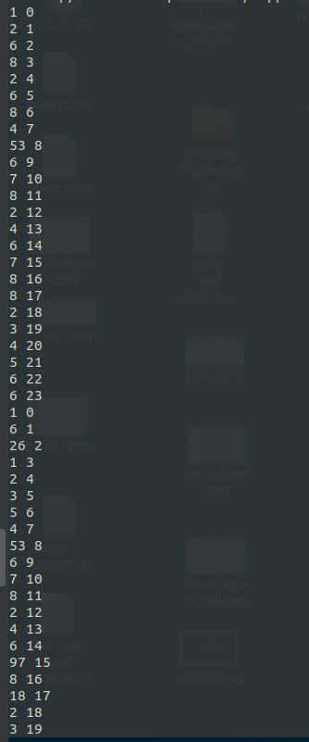

Reducer

